

**Nanoparticle Color**

## Overview:

Students will obtain a general understanding of the electromagnetic spectrum and understand the energy-wavelength tradeoff of light. Students will explore how small (nanoscale) sizes can interact with light to create macroscopic color.

## Essential Questions:

What is the electromagnetic spectrum (EM)? How do parts of a light wave affect energy or travel distance? How does nanoparticle size impact the wavelength of light it interacts with?

## Goals:

Students will:

* Goal 1: Students will be able to identify parts of the electromagnetic (EM) spectrum.
* Goal 2: Students will understand the energy vs wavelength tradeoff for light.
* Goal 3: Students will explore how arrangement of atoms can impact their interaction with light.

## Research Connection:

Understanding how light interacts with nanostructures is important, both in designing materials with desired properties, and to characterize (or see) how these tiny, nanoscale structures impact macroscopic properties.

## Safety:

There are no safety concerns.

## Materials / Preparation:

* Access to a computer
* Access to the corresponding Jupyter notebook (can be run as a Google Collab notebook if Python is not installed)

## Introduction:

1. Have students take a moment to think about how they define light. Ask questions like “What does light mean to you?” Have them come up with some examples of light or definition and write it down in their science journals. Once they have done individual thinking, have them confer with their neighbors and discuss any differences.
2. The scientific definition of light is *electromagnetic radiation*. Light can be thought of as a wave. **Waves** have certain characteristics that are important when discussing their qualities. Like a wave that crashes onto the beach, the size or strength of the wave is determined by the height, which we call amplitude. Waves are also periodic, like ripples in water, meaning they repeat. The distance between peaks (or crests) in the wave is called wavelength, which we often denote as a 'lambda': 𝜆 . For light, this wavelength determines how much energy the light contains.

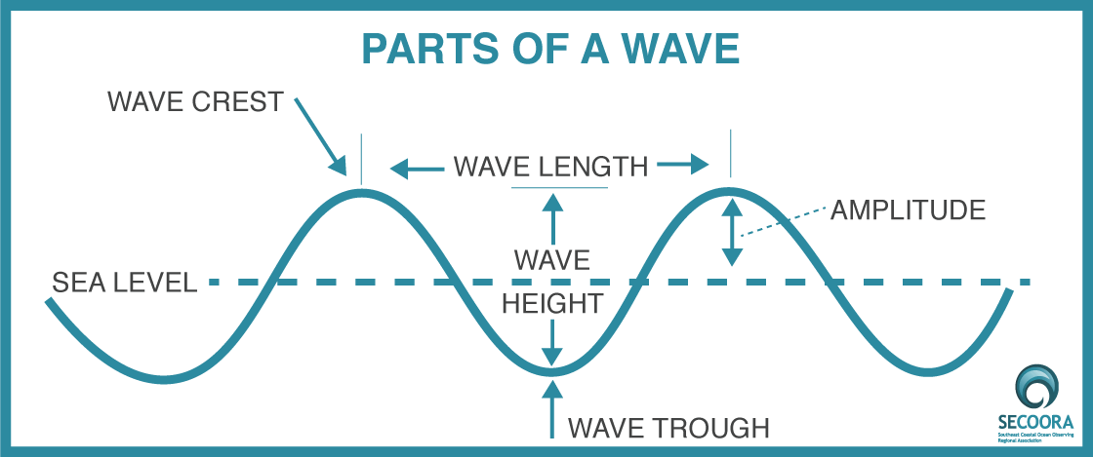

1. **Energy versus frequency versus wavelength.** Light includes radio waves, microwaves, visible light, X-rays, and gamma rays. All light falls on the "electromagnetic spectrum," or EM spectrum for short. What human eyes see is called "visible light" and is only a small section of the entire spectrum. Ask students to think of some sources of light.

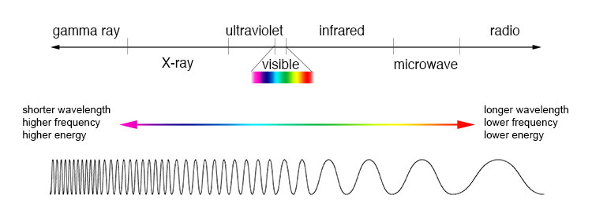

1. (Optional) **Calculation**. We can use the speed of a wave to calculate its frequency, which is defined as 𝑓=𝑣𝜆 where 𝑣 is the speed of the wave (in meters over seconds, 𝑚/𝑠 ) and 𝜆 is its wavelength (in meters, m). The units of frequency are thus inverse seconds ( 1/𝑠 ), which we denote as a Hertz (Hz). The speed of light is a universal constant (c = 3∗10^8 𝑚/𝑠 ). Radio waves have wavelengths between 1 mm and 10,000 km. Let's say you have a radio wave with wavelength ( 𝜆 ) of 1 m. Take a moment to calculate the frequency of this wave using its speed ( 𝑣 = c = 3∗10^8 𝑚/𝑠 ) using the formula above. What is it's frequency in inverse seconds ( 1𝑠 , or Hz)? (**Answer: 3*10^8 Hz**) *Challenge: unit conversions (𝜆 = 1 km or ask for answer in GHz)*



1. **4G versus 5G**. So why do we use radio waves for, well, the radio? Why can't we use X-rays to send our favorite music artist across the city? This phenomenon is the same reason why your Bluetooth headphones can't connect when far away from your phone and why Wi-Fi is so local. It has to do with the inverse proportionality between energy and distance a wave can travel. High energy waves (small wavelength and large frequency) like X-rays interact with things much more, whether that be mountains, buildings, or your broken bone that you've gotten X-rayed. Thus, they only travel short distances before they interact. This phenomenon is called attenuation. However, low energy waves (longer wavelength and small frequency) like radio waves don't interact with many things, allowing them to travel farther distances. 4G (fourth generation) cellular data is in the range 600 MHz (mega-Hz, which is 106 Hz) to 2.5 GHz (giga-Hz, which is 109 Hz). This range is lower in frequency (and thus lower in energy and larger in wavelength) than 5G (5th generation). That means 5G can have faster connection, but cellular towers need to be closer, in this case within line-of-sight of receivers (like your phone).

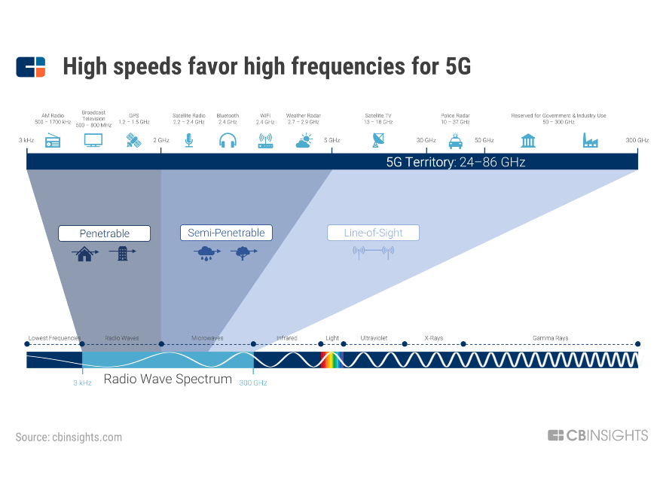

## Main Activity:

* + - 1. Create your own 1D (one-dimensional) nanoparticles that emit your desired color of light. See corresponding Jupyter Notebook.

## Post Activity Recap: *(optional)*

The previous activity was a simple demonstration of a few factors that impact nanoscience, but reality is way more complicated. **Nanostructures impact macro-properties (but sometimes they don't)**. Here are some possible nanostructure properties that scientists can change:

* Size
* Shape
* Arrangement
* Composition

Specifically, most scientists are interested in how these properties affect the material's macro-properties, such as:

* Interaction with light
* Magnetism/ magnetic susceptibility
* Electrical conductance
* Electrical resistance/ superconductivity

Sometimes nanostructures impact macroscopic properties, but sometimes they don't. This fact makes it difficult to predict what nanoscale properties will yield the desired macro-effect and hence why researchers are needed to explore this space.

* + - 1. **Living in a 3D world**. In the previous activity, we had you place atoms in a one-dimensional lattice. However, we live in a three-dimensional world, so crystals are really in three dimensions. Things can get pretty complicated in 3D, but thankfully, there is a limited number of crystal structures that exist. The simplest three-dimensional structures are the six "platonic solids", meaning each side of them is the same, regular (equal-sided) polygon.

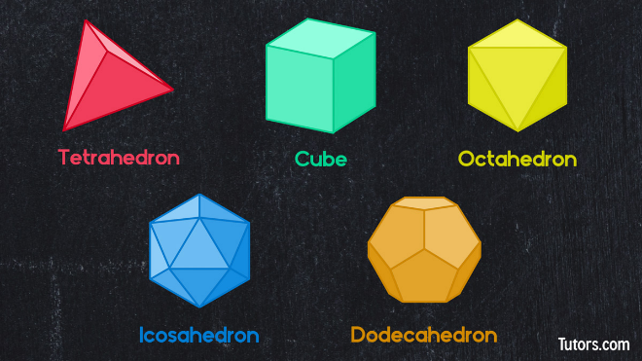

However, there are 13 "Archimedean solids", which are polyhedra with sides composed of more than one regular polygon.

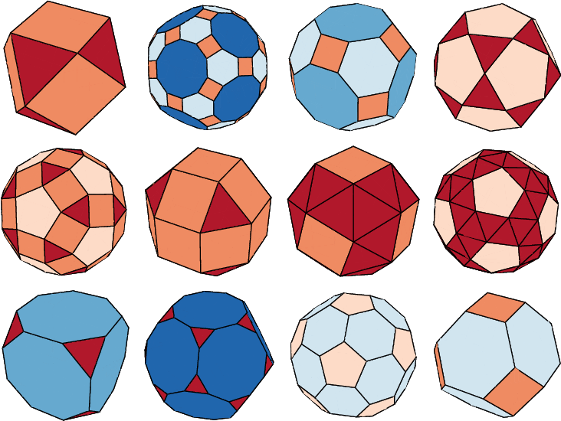

*Ask students if there are any shapes that look familiar to them.*

* + - * 1. **Fun fact:** the "soccer ball"-shaped nanoparticle, when made from purely carbon atoms, is called a "Buckyball" and is currently undergoing research for applications for drug delivery. [1]
  1. **Fun fact:** Plato associated the solids with the five elements: tetrahedron is fire, hexahedron is earth, octahedron is air, dodecahedron is spirit, and icosahedron is water. The book *Euclid's Elements* culminates in the proof that those five are the only platonic solids.
  2. **Fun fact:** Dungeons and Dragons (D&D) dice are all platonic solids (besides the d10).
  3. **Fun fact (advanced):** Each platonic solid is "dual" to another platonic solid. That is, if you replace faces with vertices and vice versa, they're identical to another. Icosahedra have 20 faces and 12 vertices while dodecahedra have 20 vertices and 12 faces. Hexahedron and octahedron are dual, and tetrahedron is dual to itself.
     + 1. Research is currently underway for "two-dimensional materials." These materials can be made into such thin layers they are only one atom thick! The most famous example of a 2D materials is graphene, which is a single atomic layer (sheet) of graphite (which is in your pencil. Graphene is made from carbon and is extremely strong. See the classic "honeycomb" lattice of graphene below.

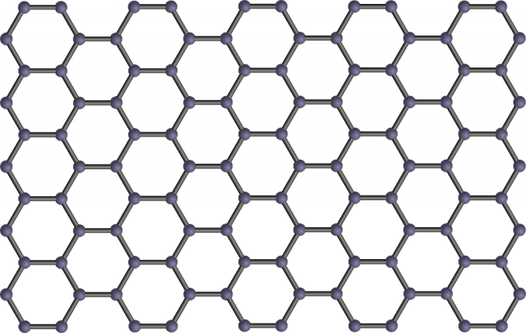

* + - 1. This research could pave the way for high temperature superconductivity, which would propel scientific instrument technology. Moreover, superconductivity is what powers high-speed maglev trains, creating the most eco-friendly (and fastest) passenger transportation system.

* + - 1. **Carbon nanotubes are considered "1D".** Carbon nanotubes are long columns of carbon arranged into a tube-like shape. They are considered one-dimensional as the diameter of a typical nanotube is less than 50 nanometers. Scientists are interested in their strength. Additionally, artists have used carbon nanotubes to make the "blackest" black ever made (absorbing 99.965% of light). It absorbs so much light that you cannot even see shadows on a 3D image. This pigment is called "vantablack", although it is not commercially available. Scientists at MIT, however, have made their own version and are using it for optical and space science applications. [2]

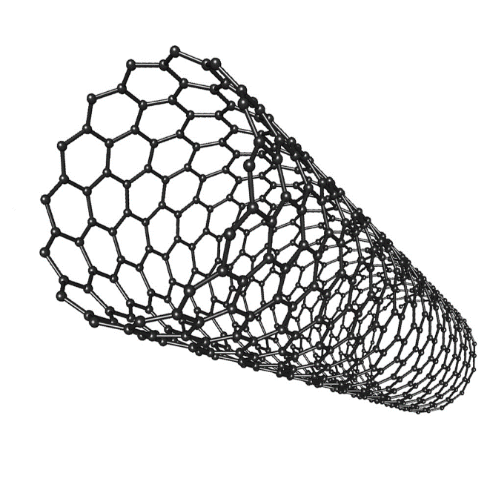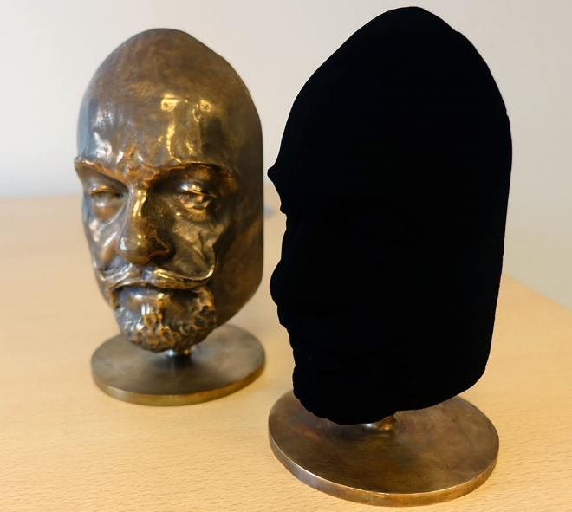

1. **Quantum dots are "0D" nanoparticles revolutionizing TV screens**. Quantum dots are (almost) spherical nanoparticles with diameters between 2 and 6 nanometers (so small!), hence why there are called one-dimensional. Depending on their size, they convert blue light into various colors in the visible light spectrum. Because they have such a small band of emission, their colors are considered more "pure". Thus, "quantum dot TVs" are currently being sold, which are said to have denser color information, allowing for the most vivid color display on the market. [3]

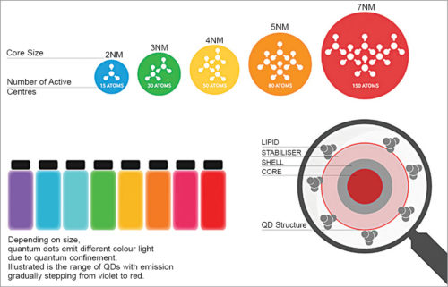

**Extensions:**

To help students further explore these concepts, consider the following extensions to either the activity or lesson plan.

1. **Discuss the wave-particle duality of light.** “An important aspect of light is the idea of particle-wave duality. This term means that sometimes light can behave like a particle (light particles are called photons) and sometimes it behaves like a wave, depending on what experiment you are performing, or how you observe it. Quantum mechanics states it is both at the same time! In fact, a famous French physicist named Louis de Broglie came up with a formula stating that everything is both a wave and particle, but the more mass you have, the more you behave like a particle rather than a wave.”

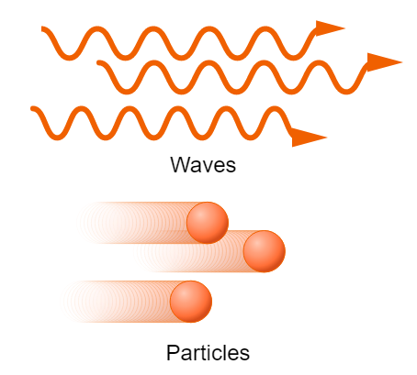

1. Archimedean solid coloring book/ fold-up patterns.

## Resources and References:

[1] <https://www.engineering.columbia.edu/news/nanotechnology-breakthrough-may-improve-drug-delivery>

[2] <https://science.howstuffworks.com/vantablack.htm>

[3] <https://avantama.com/quantum-dot-tv/#:~:text=A%20quantum%20dot%20TV%20is,using%20a%20light%2Dguide%20plate>.